Southwestern Local Area Effective Date:7/1/2017

SUBJECT: WIOA Youth Work Experience Training Policy

PURPOSE: To Establish Policy for WIOA Youth Work Experience

Background:

The WIOA Youth Work Experience program is a planned, structured learning experience that occurs in a workplace for a specified, limited period of time. The purpose of the Work Experience activity is to provide the WIOA Title I participant with opportunities for career exploration, skill development, and reinforcement of the work ethic.

LOCAL AREA POLICY GUIDELINES:

Work Experience (WEX) Assessment and Training Plan
The service provider shall ensure that WEX training for WIOA Title I eligible participants is appropriate based on the needs identified by an objective and comprehensive assessment and as documented in the Individual Employment Plan/lndividual Service Strategy (IEP/ISS). The WEX IEP/ISS should clearly indicate how this activity is going to help the participant move from the WEX to unsubsidized employment or on to further training. Documentation of the need for work experience that is tied to and supported by academic and occupational education and the objectives of the work experience must be detailed in the IEP/ISS and WEX Training Plan, if one is utilized.
Periodic evaluation of the participant's learning and attainment of skills during the work experience, including information about any incentive payments made, should be documented in case notes in NCWorks Online. When possible, it is strongly encouraged that the WEX and its associated training components be directly tied to the attainment of a credential and documented in the IEP/ISS. Program providers should use either O*NET or other identified programs when developing the competencies to be learned and evaluated in the WEX. The IEP/ISS should include the job skills needed, training hours, and estimated start and end date. Youth academic and occupational components must be included.
The maximum duration of the work experience should be specified per program year. The determination of the duration of the WEX should be based on the academic and occupational competencies the WIOA participant needs to develop or refine and must be specified in the IEP/ISS and WEX Training Plan, if one is utilized. Academic skills training could be basic skills education or high school equivalency training. Occupational skills competencies may be gained through the WEX, HRD classes or through courses specific to the job/career/occupation in which the individual is having the work experience.
A WEX Training Plan if developed in conjunction with the IEP/ISS allows service providers to monitor and evaluate the WEX. It serves as a baseline when establishing whether the needs of the WIOA participant and the employer's expectations of training and development have been met.

Youth Work Experience Opportunities
Pursuant to WIOA section 129(c)(2)(C), local Workforce Development Boards (WDB) are required to offer youth programs that involve paid and/or unpaid work experiences that have as a component both academic and occupational education. The educational component may occur concurrently or sequentially with the work experience. Further academic and occupational education may occur inside or outside the work site. Work experiences provide the youth participant with opportunities for career exploration and skill development. These experiences may include:
(1) Summer employment opportunities and other employment opportunities available throughout the school year;
- Pre-apprenticeship programs;
- Internships and job shadowing

Recognized best practices for engaging youth in work experiences:
(l) Programs prepare youth for work experiences through training and guidance in soft skills. Youth programs engage young adults in training or class activities that develop these soft skills. This may include learning about professional work culture, working in teams, interpersonal skills, and communication.
- Some programs also train youth in technical skills or hard skills needed for specific career pathways or work settings. Youth will learn skills specific to an occupational sector.
- Program staff devote significant time to developing and maintaining relationships with employers. Dedicated staff (job developers) may handle all aspects of employer relations, from making an initial inquiry about partnering to establishing worksite agreements with employers, to responding to any employer concerns during the work experience.
- Programs clearly communicate what is expected of employers, youth, and families before the start of a work experience to include mentoring the youth and providing feedback to the program coordinator. Some programs address the importance of work in life, how the program helps youth make a successful transition to work, what employers expect of workers, and how to appropriately interact with employers.
- Programs carefully match youth to work experience opportunities based on individual interests and skills. Making the right match increases the success of the work experience by ensuring that youth feel motivated from the start to participate fully.
- Programs provide on-going support to youth and employers throughout the work experience. To ensure a work experience is successful for everyone involved, programs maintain communication with both the youth and employers from the first to the last day of the WEX. While some programs have daily or weekly contact with youth to monitor their progress, other programs conduct first-week, midpoint, and last-week work site visits at a minimum.

Youth Work Experience — 20 Percent Spending Requirement
Local youth programs must expend not less than 20 percent of the Title I youth funds allocated to them to provide in-school youth and out-of-school youth with paid and/or unpaid work experiences.
Local WIOA Title I youth programs must track program funds spent on paid and unpaid work experiences, including wages and staff costs for the development and management of work experiences, and report such expenditures as part of the local WIOA youth financial reporting.
The percentage of funds spent on work experience is calculated based on the total local area youth funds expended for work experience, rather than calculated separately for in-school and out-of-school youth. The 20 percent spending requirement is calculated after administrative costs have been subtracted from the total amount of youth funds.

Wages
Individuals participating in a work experience opportunity must be compensated at the same rates, including periodic increases, as trainees, or employees who are similarly situated in similar occupations by the same employer and who have similar training, experience, and skills. The rates may not be lower than the higher of the federal or state minimum wage.
A flat rate wage applied to all individuals participating in a paid work experience opportunity (e.g. $8.00/hour for all participants) would not be allowed if there are trainees or employees who are similarly situated in similar occupations with the same employer who receive wages that differ from the flat rage wage.
Wage requirements under the Fair Labor Standards Act (FLSA) apply to all youth employed under WIOA. The FLSA applies to the extent that the activities performed in the work experience constitute employment. WDBs must determine whether work experience constitutes training as opposed to employment. Please contact a Certified Public Accountant for more information.

Choosing a Worksite
Matching a WIOA participant with the appropriate worksite is critical to a successful WEX job assignment. Worksite supervisors need to have a clear understanding of the objectives of the WEX job assignment and realistic expectations of the work products and productivity that a WIOA participant may demonstrate. The participant must have adequate supervision, as any other entry-level employee. The worksite must be willing to allow Board staff, the North Carolina Division of Workforce Solutions and/or US Department of Labor to perform onsite monitoring to ensure compliance with the worksite agreement, as well as, to monitor the progress of the participant.
WDBs should use discernment when choosing worksites. When choosing employers, analyze the "value added" contributions an employer is willing to make to the experience for the participant. Examples of such contributions are structured development/refinement of work readiness skills, provision of on-site educational services, and exposure to enhanced skill training and mentoring.
The Division strongly discourages the practice of placing participants in WEXs located at the board office, career center, or administrative entity due to the potential of conflicts of interest. Placement at these locations should only be allowed where there is specific documentation in the file that the particular experience meets the participant's career goals and skills needs AND there is no other placement opportunity available.

Skills Analysis / WEX Training Plan Development
An individualized WEX skills analysis must be performed to determine the acquisition of skills that the participant does not already possess. Skills the participant may have acquired from previous work or life experiences are potentially transferrable and can be used in every occupation, regardless of the type of work. Transferrable skills are unlike job-related skills, which tend to be used only in one type of work.
This analysis will contain occupationally specific skills that the employer requires for competency in the WEX occupation. An analysis of the trainee's prior work history, transferrable work skills, and the job skills gained must be compared to the job skills/job description the employer requires in the WEX occupation. The resulting gap in skills will be the basis for the development of the WEX.
There are a number of assessment tools available that may be used to conduct a skills gap analysis and provide adequate documentation of the process utilized. These include Prove It! TM , an Internet—based assessment tool used to determine an individual's level of skills in a particular occupation and to document skill deficiencies, as well as the O*NET Online website and www.myskillsmyfuture.org which have both been developed by the U.S. Department of Labor.
The sample WEX Trainee Evaluation Form may also be used at the conclusion of training to document the mastery of the required skills. Completion of the final skills evaluation section of the form signals the successful completion of the WEX.

The Worksite Agreement
There must be a WEX Worksite Agreement between the service provider and the employer that articulates the learning that is to take place, the length of the WEX, and the academic and/or occupational competencies to be obtained. The Worksite Agreement must be completed and signed prior to the start of the WEX. The service provider will use a standardized Worksite Agreement template (sample provided as Attachment 2) developed by the WDB staff. Additionally, the service provider must provide documentation that the employer received formal WEX training.
The purpose of the worksite agreement is to establish a formal training relationship with a worksite, to specify the responsibilities of each party to the agreement, and to provide a successful, enriching WEX job experience for the WIOA participant. A signed original of the Worksite Agreement should be on file at the worksite and the provider should maintain all WEX documents and case notes in NCWorks Online.
The following items are the minimum required terms and conditions of a Worksite Agreement. Other specifications or terms specific to the worksite may be added as needed.

Work Experience (WEX) Contract Requirements
l) Work Experience contracts require that the wages paid to participants be at least the prevailing entry wage for any specific occupation in the community.
- The employer must comply with requirements of the Civil Rights Act with respect to equal opportunity in employment for the WEX position, as well as comply with all federal, state, and local laws.
- The WIOA Service Provider or WDB must have Workers' Compensation Insurance coverage and make federal and state tax withholdings as required by law, as applicable. In addition, the individual trainee payroll tax records must be maintained and available for review for a minimum period of three years after the end of the training period. (The North Carolina Workers' Compensation Act requires that all businesses that employ three or more employees, including those operating as corporations, sole proprietorships, limited liability companies and partnerships, obtain Workers' Compensation Insurance or qualify as self-insured employers).
- Conditions of employment and training will be in full accordance with all applicable federal, state, and local laws (including but not limited to health and safety laws), and be appropriate and reasonable with regards to the type of work undertaken and the proficiency of the participant
- The employer must certify that the participant will not displace any regular employee of the employer and that no person was displaced as a result of the relocation of the current business within the previous 120 days of signing the WEX Worksite Agreement.
- The WEX employer will agree to adhere to the local WDB's grievance process if a complaint arises in connection with the WEX participant and/or the training.
- WEX participants will not be employed to carry out the construction, operation or maintenance of any part of a facility that is used or to be used for sectarian instruction or as a place for religious worship, or be required to participate in religious activities.
- Participants may not enter a WEX position if a member of his/her family is engaged in an administrative capacity with the WEX employer, including a person with selection, hiring, placement, or supervision responsibilities for the WEX trainee.
- The provider must certify that neither the employing company nor its principals are presently debarred, suspended, proposed for debarment, declared ineligible, or excluded from participation by any federal department or agency.
- A participant may not be trained under a WEX Worksite Agreement at a particular employer if:
  - any other individual is on layoff from the same or substantially equivalent job;
  - the employer has terminated the employment of any regular, unsubsidized employee, or otherwise caused an involuntary reduction in its workforce with the intention of filling the vacancy so created with the WIOA participant; or
  - the job is created in a promotional line that infringes in any way on the promotional opportunities of currently employed workers.

40 hours a week for WEX is the max 480 hours max contract

EFFECTIVE DATE: IMMEDIATE

EXPIRATION: INDEFINITE

CONTACT: David Garrett

Attachments: Worksite Agreement
Worksite Agreement Trainee Evaluation

Attachment 1 Effective Date: 07/01/17
Southwestern Workforce Development Board
Workforce Innovation and Opportunity Act (WIOA) Work Experience Worksite Agreement
This Agreement is made between (WIOA Title I

Service Provider) and
(WIOA Worksite) a public or non-profit or a private for-profit business or organization to provide subsidized or unsubsidized internship/work experience to eligible youth participating in the Southwestern Workforce Development Program, authorized and funded under the Workforce Innovation and Opportunity Act (WIOA). Under this Agreement, participants will be provided a short-term work experience which is valuable and meaningful for both the participant and the organization/worksite.
Work Experience job assignments will be consistent with each WIOA participant's capabilities and interests and in an occupational field or specific job in which he/she has minimal or no prior work experience. WIOA-funded Work Experience job assignments are expected to help individuals gain the skills and experience they need to succeed in the workplace and obtain unsubsidized employment.
Term: This agreement will take effect on [date] and terminate no later than [date].

This Worksite Agreement provides the following assurances:
l. There will be sufficient, meaningful work to keep WIOA participants fully occupied during work hours;
- Work will be conducted in a safe work environment;
- There will be adequate full-time supervision of each WIOA participant by qualified supervisors;
- The Service Provider or Workforce Development Board will obtain Worker's Compensation Insurance to cover all WIOA participants engaged in internship or work experience at a worksite;
- The participating Worksite will notify WIOA Service Provider staff if difficulties arise which the Worksite supervisor and participant are unable to resolve. WIOA Service Provider staff will attempt to find a mutually satisfactory solution. The WIOA Service Provider staff and/or Worksite supervisor may recommend termination or transfer of the participant if the situation or problem is not resolved;
- There will be adequate oversight and review of each participant's time and attendance;
- There will be sufficient equipment and/or materials provided to carry out assignments;
- This agreement will be maintained at the Worksite and available for review by federal, state, and WDB representatives;
- All requirements and regulations governing the WIOA program will be upheld; 10. Worksite supervisors will adhere to existing state and federal labor standards; l l. The participating Worksite has not relocated this establishment and commenced operations in the past 120 days, where the relocation resulted in the loss of employment at the original location;
- No WIOA participant shall be employed or job opening filled (A) when any other individual is on layoff from the same or any substantially equivalent job, or (B) when the Worksite has terminated the employment of any regular employee or otherwise reduced its workforce with the intention of filling the vacancy so created by hiring a participant whose wages are subsidized under this Act;
- Equal Employment Opportunity and Nondiscrimination: The Worksite assures that no person on the grounds of race, creed, color, disability, national origin, sex, age, political affiliation, or beliefs, will be excluded from participation in, be denied the benefits of, or be subjected to discrimination under any program or activity funded in whole or in part with funds made available under the Workforce Innovation and Opportunity Act;
- The Local Workforce Development Board will determine payroll responsibility.

Work Activities
A written job description must be attached to this Agreement. The job description must include:
(l) Accurate description of required duties and responsibilities;
- Hourly wage for position;
- The days and hours to be worked (not to exceed 40 hours per week).
If the WIOA participant's job duties at the Worksite change, the Worksite agrees to notify the WIOA Service Provider immediately so that this agreement may be modified.

Time and Attendance and Rate of Pay
Accurate time and attendance records will be kept by the Worksite supervisor for each WIOA participant. Records will reflect the time actually worked by the participant. Participants will not be paid for time not engaged in work duties, including absences, lunch periods, vacation time, or holidays.

Monitoring
It is mutually understood and agreed that the WIOA Worksite may be monitored by the [Local Area WDB], NC Division of Workforce Solutions, and/or the US Department of Labor. The WIOA Service Provider will monitor the Worksite based on a planned schedule at least once during the term of this agreement. The Worksite supervisor will maintain current and accurate time and attendance records and will cooperate fully to provide staff with worksite information or records as required in a timely fashion.

Supervision
Worksite supervisors must be experienced in the work to be performed by the WIOA participant and in supervising entry-level employees. Worksite supervisors should encourage and expect participants to demonstrate, good work habits, satisfactory job performance, and positive attitudes about work.

Authorized Signatures:

Worksite Representative

Print Name Signature Date
Printed Title
Worksite Business Name and Address:
WIOA SERVICE PROVIDER:

Print Name Signature Date
Printed Title
WIOA Service Provider Name and Address: ___ ___________________ __________________________________
___________________________________

Attachment 2 Effective Date :7/1/17

SOUTHWESTERN WORKFORCE DEVELOPMENT BOARD
[Insert Work Experience Provider Name Here)
Work Experience (WEX) Agreement
Section l: General Information
Please complete the folPl Please complete the following
Trainee Name: |  | Job Title:
O*NET Code: | SVP Code: | Hourly Starting Wage: |  | Hourly Ending Wage:
Maximum Training Hours: | Worksite Name: | Worksite Address:
Trainee Supervisor: | Title: |  | Phone: Email:
Employer Representative Name: | WIOA WEX Agency Representative: |  | WIOA WEX Agency Representative  Contact Info:
Pay Schedule:  Weekly Monthly  Bi-Weekly Other | Pay Day:  Period Covered: |  | Ratio Of Trainees To Supervisor:

SOUTHWESTERN WORKFORCE DEVELOPMENT BOARD
[Insert WEX Provider Name Here]
Work Experience (WEX) Agreement: Trainee Evaluation
Trainee Name: Supervisor Name: Company Name:
Section l: Evaluation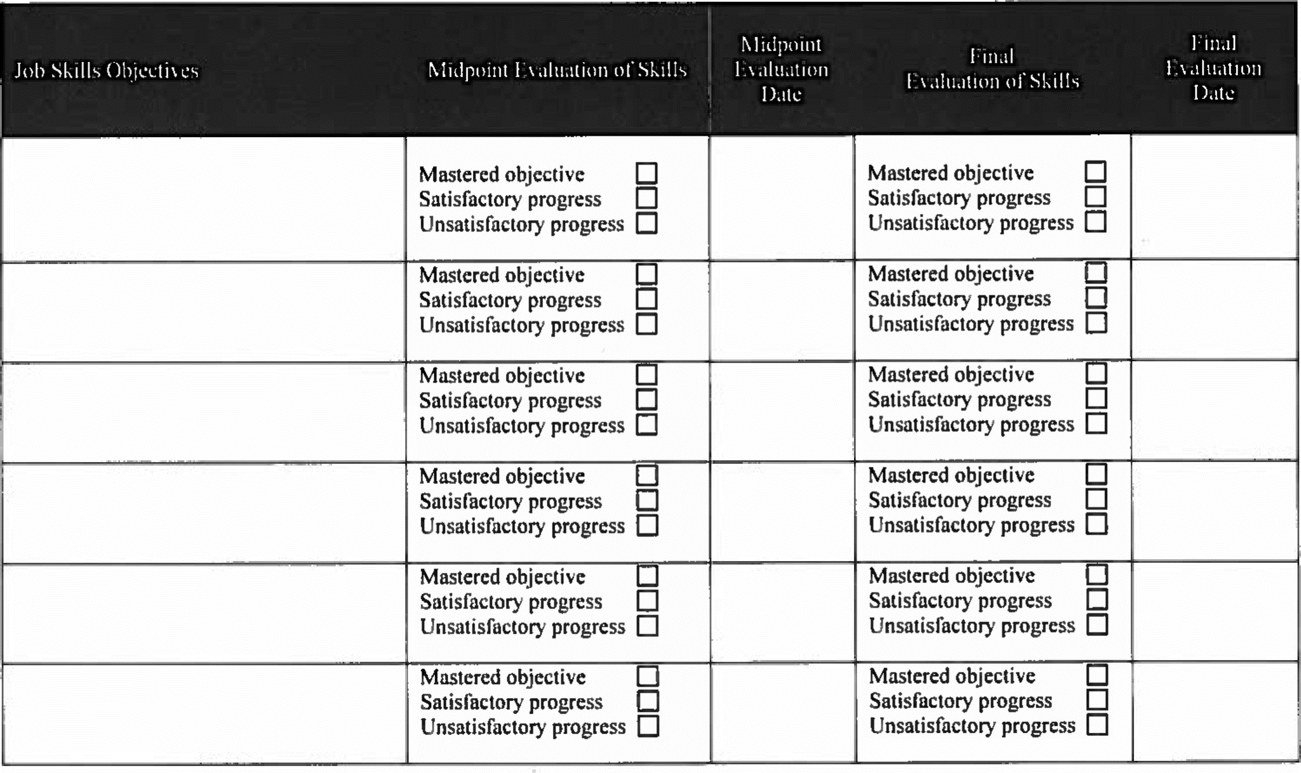
Section 2: Authorized Signatures
Midpoint Evaluation Final Evaluation
I hereby certify that the above information is accurate |  |  | I hereby certify that the above information is accurate.
Employer Signature: | Date: |  | Employer Signature: | Date:
Supervisor Signature: | Date: |  | Supervisor Signature: | Date:
Trainee Signature: | Date: |  | Trainee Signature: | Date:
Section 3: Comments (please explain any unsatisfactory evaluation items)

